Assume you tested the medicament on 8 people, 4 of whom received it, 4 others received

a placebo (something that looks like a medicament, but contains no active ingredient).

Assume 3 of 4 med-receivers improved their illness after 1 week. But also 3 of 4 placreceivers improved their illness after one week, .... hmm: obviously this medicament you don't really need!

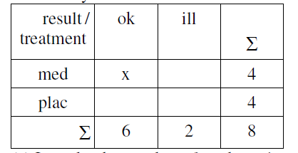

(a) Let x be the number of med-receivers that get healthy given the “marginal sums”,

4, 4, 6, 2 (as in the table). Assuming independence, calculate the probability that x = 3

(careful: this has nothing to do with Ex. 1.) Fill out the rest of the table. Do you think

independence is true? Do you think independence is wanted?

(b) Fill out the table for x = 2, 3, 4 (more is not possible) and calculate the corresponding

probabilities. Do they sum up to 1?